Find a notes style that works for you. See examples below. I recommend hand written notes because studies have shown that hand writing notes improves memory retention.

You will be expected to read and take notes almost every night. You need to keep up with the reading since you will need the information to be prepared for the next class.

**MIND MAPPING**

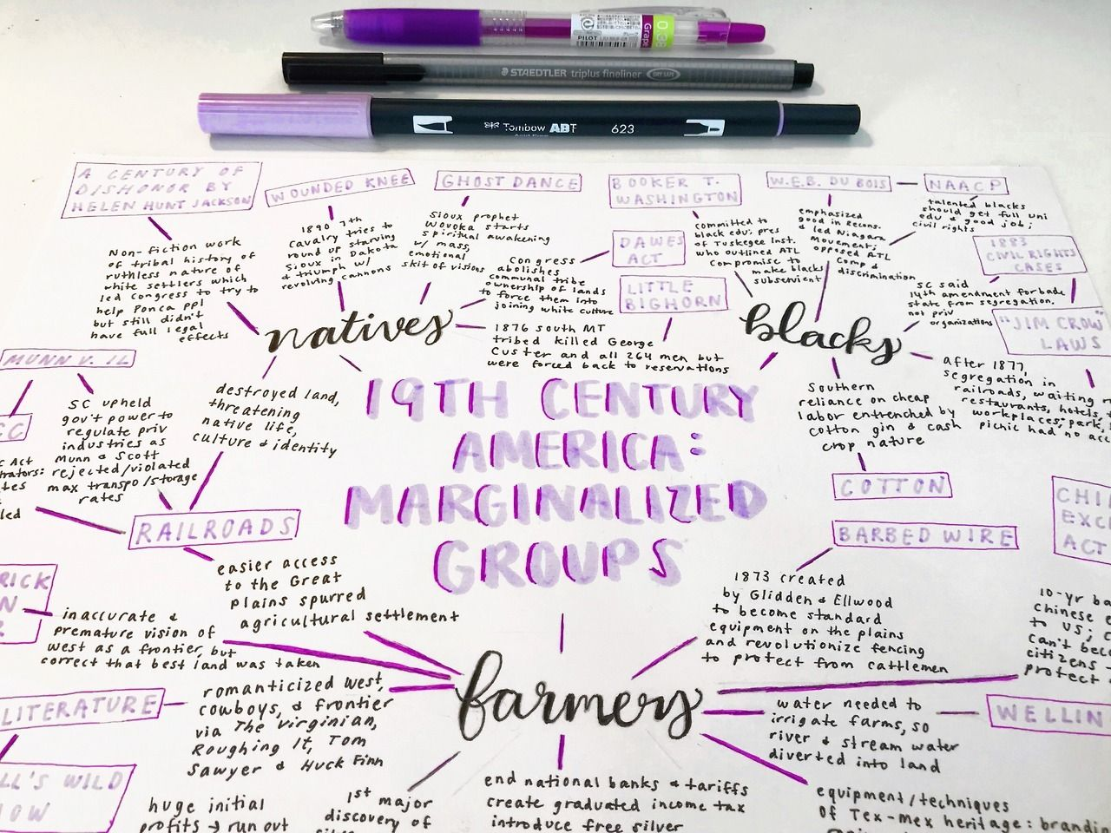

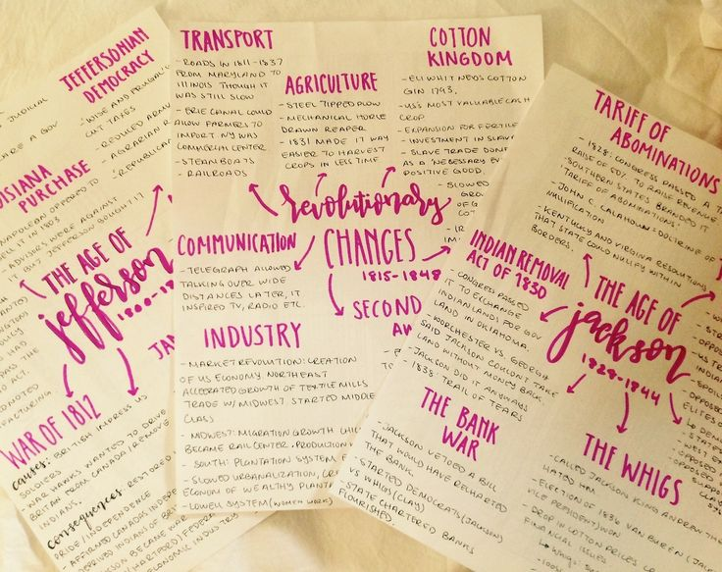

**Cornell Notes**

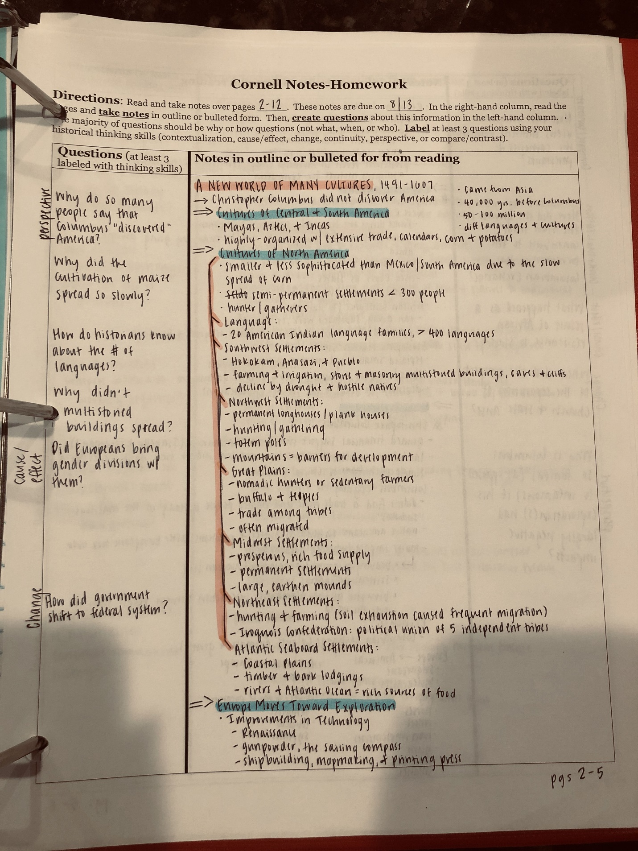

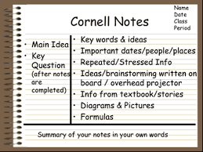

**Outline:**

